Blokus Duo: Using Deep Search Algorithms to Explore Turn-Based Game Strategy

Jake Frischmann, Etash Jhanji, Micheal Huang, Sebastian Liu, Alden Bressler, Delia Brown

Abstract
This paper evaluates several algorithmic approaches to playing Blokus Duo, a two-player variant of the strategy game Blokus. We implemented and compared four methods: minimax, Monte Carlo Tree Search (MCTS), MCTS enhanced with a convolutional neural network (CNN), and Proximal Policy Optimization (PPO). Each algorithm was trained and tested through large-scale self-play simulations and evaluated against both random agents and human players.
Our experiments show that minimax occasionally performed well against humans but was computationally impractical due to the game’s large branching factor. PPO achieved moderate success against random play but failed to develop meaningful long-term strategies. Standard MCTS proved stronger but was consistently outperformed by MCTS with CNN, which achieved win rates of 66% as player 1 and 48% as player 2 against the standard MCTS agent. Importantly, the CNN-enhanced MCTS was the only model able to consistently defeat experienced human players.
All code was written in Python using Jupyter notebooks, with training and evaluation results stored and shared via GitHub.

I. Introduction

A. The Game of Blokus
Blokus is a turn-based strategy board game in which players attempt to place their inventory of 21 unique polyominoes onto a limited grid. Each set consists of pieces ranging from one to five squares in various configurations (Figure 1).

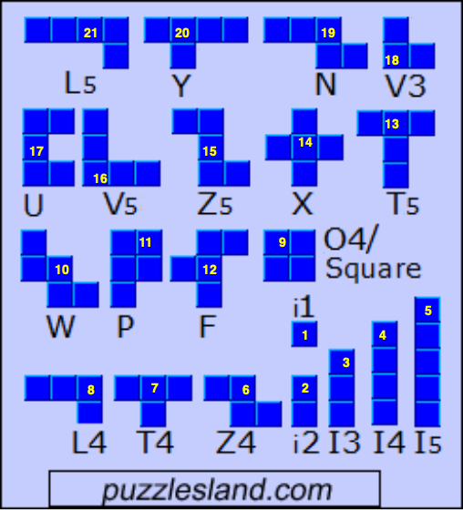
Figure 1: Labeled Inventory of 21 Polyomino Pieces¹

Players take turns placing one piece onto the board. Aside from their starting move, a player can only place pieces by connecting a corner of the piece they are playing to a corner of one of their previously placed pieces. Additionally, the edges of the placed piece may not touch the edges of any placed piece of the same color. Each piece may also be flipped or rotated in 90-degree increments before placement. The game ends when both players are unable to play more pieces. If only one player has run out of possible moves, the other player will keep playing until they too run out of moves. After the game ends, the player with the greatest total squares placed on the board wins.

Traditionally, Blokus is played with four players. However, there exist multiple variations, including a two-player version called Blokus Duo which was used for this project since one-versus-one games are better suited for simulations and computer algorithms. Blokus Duo accounts for the lower number of players by having a board size of 14 by 14 squares, smaller than the traditional board’s 20 by 20 squares. Another difference between traditional Blokus and Blokus Duo is the starting positions. In traditional Blokus the players each start by placing a piece that touches a corner of the board, whereas Blokus Duo requires each player to start by placing a piece that covers one of the two indicated starting tiles, which are at positions (5, 10) and (10, 5). In Blokus Duo, the two opponents generally have orange and purple-colored pieces.

B. Coding Environments & Language
We chose to write our project in Python because of its ease of use and accessibility to packages such as pandas and numpy, both of which made the entire process faster. Further, Python is the most popular language for machine learning purposes, which allowed us to explore this possibility. Development of code was done on Replit, an online integrated development environment that allowed our team to easily collaborate on the project. Further work was done on Visual Studio Code, a code editor developed by Microsoft, especially regarding data collection over a simulation of millions of games. For source control, we used Git, and our open-source code will be provided on a GitHub repository provided in a later section.

C. App Intro, User Interface & Playing the Game
To best demonstrate the results of our project, we created an app using PyGame, a Python package used for game development, where humans can play a game of Blokus Duo against our computer algorithms. Following is an account of the app and how the user interface works. When a human plays against the computer, they see a 14 by 14 grid on the screen, which has an orange dot on the square of the grid marking where the human user must start their first move, and a purple dot on the square which marks where the computer must place its first move. The inventory of the human player is in orange, while the computer plays purple pieces. The app can be set to decide whether the human player or the computer algorithm gets the first turn, but that can not be changed by the user and must be changed directly in the code. To play a piece in our app, the user types in the number of the piece they want to play, and once they press enter the inputted piece appears on the screen. The player can drag their selected piece to where they wish to place it and can click the screen to commit the piece onto the board. Before placing the piece the player can rotate the piece by pressing the R key until the piece has the orientation that they want to use. Once a piece is played, by either the human or the computer, dots of the color of the piece played appear on the screen in the squares that are the corners of the played piece. These colored dots signify the available moves for the player of the same color. At the bottom of the screen, right under where the player types in which piece they want to place, a colored dot indicates which player’s turn it is. On the bottom left side, the total number of squares placed by each player is displayed, which represents their score. The program will stop running once both players have run out of moves and the game has ended. Figure 2 shows how the app will appear mid-game.

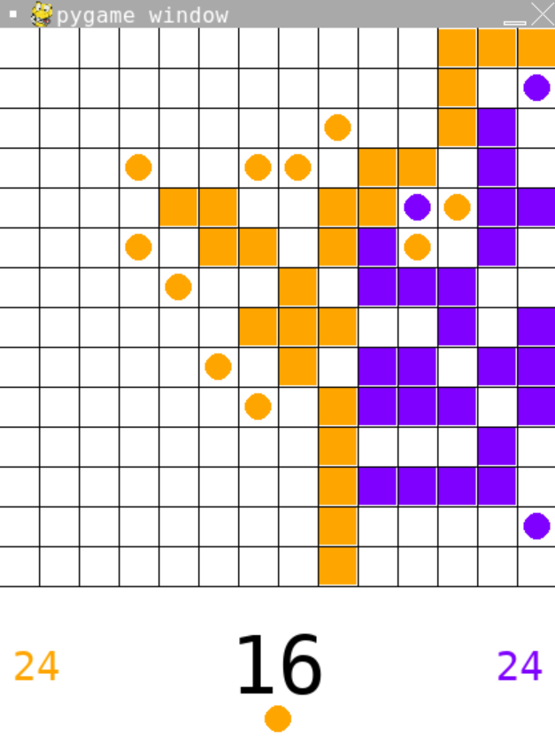
Figure 2: PyGame App Mid Blokus Duo Game

D. Optimizing Play: Project Aims

1. Optimization Introduction
The challenge our team underwent was to see if an algorithmic approach could be used to create a theoretically optimal Blokus player. Optimization has long been an important facet of competitive gameplay, and through advances in machine learning, full optimization has become theoretically attainable. There are multiple historical examples of Artificial Intelligence being used to create an optimized computer algorithm. The first well-publicized achievement of a turn-based algorithm was IBM’s Deep Blue which, in 1997, became the first chess engine to defeat a world chess champion, Garry Kasparov^{2,3}. Deep Blue used the minimax algorithm which will be explained later. In 2016, DeepMind’s AlphaGo defeated top Go player Lee Sedol⁴, and a similar model AlphaZero has defeated world champions in the games of Chess, Shogi, and Go⁵. Both of these algorithms used Monte Carlo tree search which will be explained in a future section. Our goal was to apply similar strategies to optimize Blokus.

We quickly found that Blokus is not a “solvable” game - it simply has too many possible moves in most board states to fully parse every way a game could play out. This is due to the heavy branching factor of the game. At the start there are 508 possible moves, at the second move there are around 2500 moves available, and by the third move there are already around 3800 available moves, with each of these moves branching into states with further possible moves. For comparison, chess has roughly 20 to 60 moves per turn, and in Go, there are around 250 moves per turn. The amount of possible moves contributes to the complexity of Blokus and demonstrates the spatial forethought and long-term planning required to succeed. Additionally, the strategies to play Blokus are also difficult for the computer to quantify. Therefore, we attempted to apply the aforementioned algorithmic strategies to create a computer program that would make the best possible move at any given point. This will be further illustrated in later sections. However, as a general principle, we tried to prioritize various goals for play that we felt were most useful for human play.

2. General Strategies in Human Play
Prior to algorithm work, the members of our team played numerous games of Blokus against each other to determine what factors human players generally deem to be of the greatest importance, as well as to determine “winning” strategies. We concluded that there were three main ideas to consider when trying to win a game of Blokus. The first goal is to create more opportunities for pieces to be played. To do this players want to increase the number of corners they have available, as having more corners allows players to have more available moves. The second goal that we found is to limit the moves of your opponent, which is achieved by blocking the corners of an opponent’s piece. One way to do this is to create a line of pieces enclosing board space that is impenetrable by your opponent. Your opponent is then blocked completely out of portions of the board. Typically, the most advantageous strategy with these spaces is to not fill them until the end of the game, and while retaining secured spaces continue “invading” more opponent space. Finally, we agreed that it was overall important to try and play the pieces with the highest amount of squares, as these pieces are worth the highest amount of points. These pieces are also generally the most difficult to fit, so it is important to try and place them down earlier in the game when there is still plenty of available board space. In the set of pieces with maximal tile count, some pieces still prove harder to place based on their shape. Difficulty of pieces would come into play in different facets of our algorithm, for example in the scoring algorithm in Section II.A.2.

Apart from relatively basic values that most players understand prioritizing, there have been more advanced strategies developed in communities around the game. For example, in traditional Blokus, the Barasona Opening is one of the most popular combinations of starting moves because it prevents opponents from penetrating one’s line of pieces without using their valuable one-piece.⁶

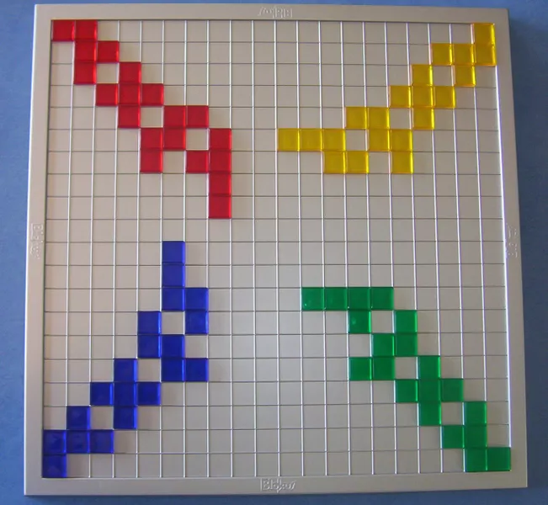
Figure 3: The Barasona Opening⁶

These concepts were too advanced to reasonably implement into our algorithms. However, the concepts researched helped examine what generally helped a player win. If interested, an excellent starting point can be found on pentolla.com.⁷

3. Translation into Computer Algorithms
We wanted to implement these human strategies into computer algorithms by using the human optimization strategies that we found to inform how our algorithms scored the board. Considering the three main human strategies outlined in the previous sections as well as further input from human play, we decided to measure several quantifiable metrics relating to the following strategies: playing pieces that are worth more, creating corners to play on, blocking opponent corners, trying to create space to be able to play in (this is a less quantifiable goal, but we attempted to consider this in our weighting philosophy), and being able to switch between playing offensively and defensively depending on the board state at any given move.

II. Approaches and Algorithms
To create an optimized computer algorithm that could play Blokus Duo, we implemented three different strategies. We implemented two tree-based algorithms, which are considered deep search algorithms. These algorithms look ahead of the current move through all possible available moves and all of the branching that comes from each decision. Deep search algorithms are useful for our purposes because of their ability to look through all (or many viable) possible moves and find the best one. The two deep search algorithms that we implemented were minimax and Monte Carlo tree search, and in this section, we will weigh the benefits and limitations of each. We will describe the development and improvement cycle that led to our final result of an algorithm that implements Monte Carlo tree search to play Blokus Duo. Additionally, we chose to implement a third algorithm called Proximal Policy Optimization that through the use of reinforcement learning, trains the model by trying to maximize the reward of the algorithm based on the actions the algorithm takes.

A. Minimax⁸
The minimax algorithm is a search algorithm that a computer player can use to consider its possible moves and determine future board possibilities of each move. Looking at all future predicted board states the algorithm then decides which move gives it the greatest possibility of winning. The name of this algorithm comes from the two opposing goals of this algorithm: the computer is attempting to maximize its score while minimizing its opponent’s score.

1. Overview
To better illustrate how minimax works, we will consider a relatively simple game: the Game of Eight. In it, players take turns adding either 1, 2, or 3 to a running total. Players may not choose the same number that was chosen on the prior turn, and the game ends when the total is brought to eight or more. If a player reaches 8 on their turn, they win, but if they exceed it, they lose. Due to the limited number of turns the game can have and the small number of possible moves per turn, a decision tree for every possible game can be drawn:
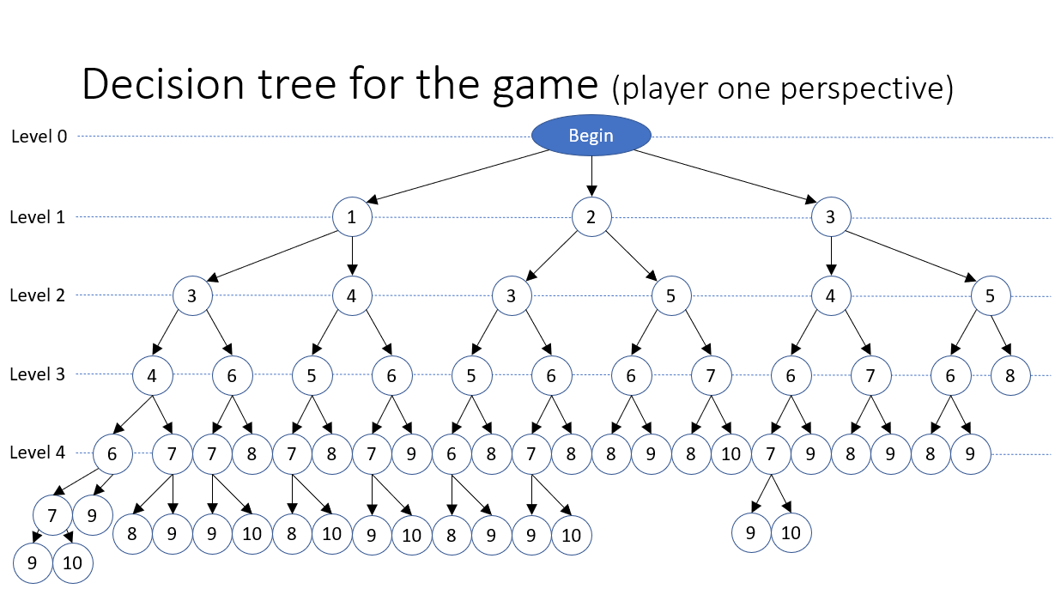
Figure 4: Decision Tree For Game of Eight

This tree accounts for every legal combination of moves. If we assume that both players are tactically perfect and understand every possible branch that the game can take then we can assume that they will always make moves that will benefit them the most. Figure 5 illustrates the possible ending states of the game and which player will win which ending:
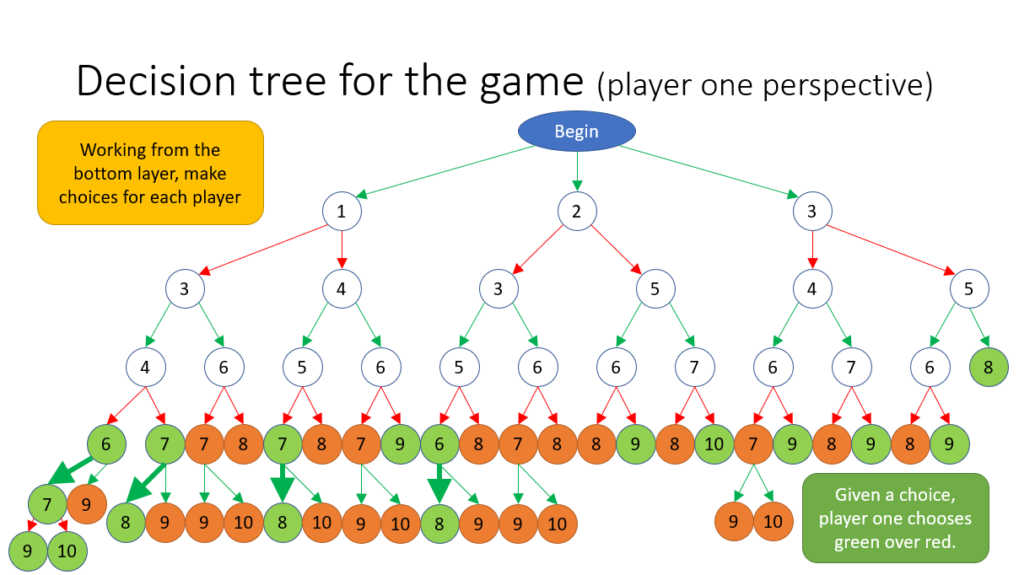
Figure 5: Game of Eight Endings by Which Player Wins

In this tree, green nodes mean player one wins, and red nodes mean player two wins. We can see that some choices will always lead to a certain player winning, and so it is clear that the optimal player will always make these choices. However, to reach a choice that guarantees victory, they must start playing the game from the beginning in a way that will lead them down the winning path. We can traverse up the tree, selecting the best move each player can choose.
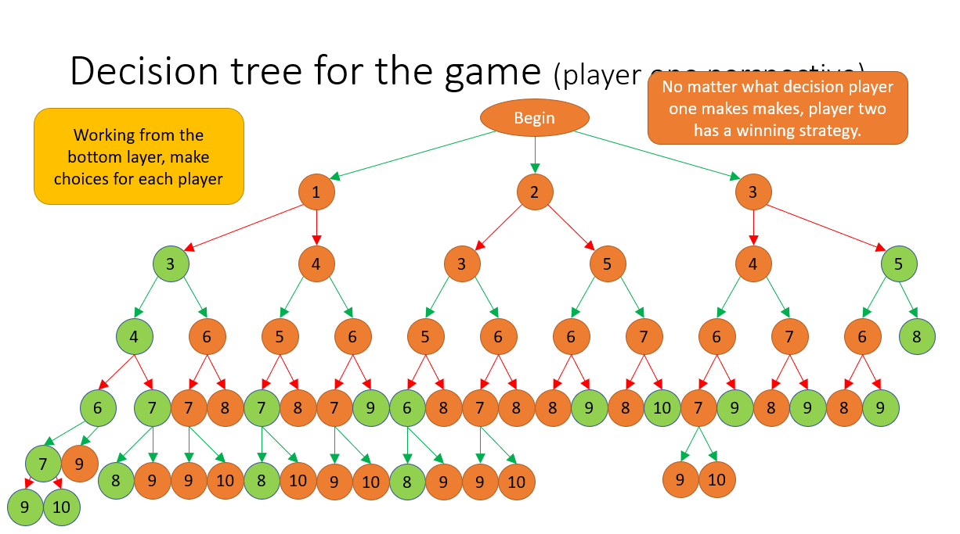Figure 6: Filled in Game of Eight Tree

In this case, there is always a path player two can take to win the game. Of course, not every game has a decision tree as small as that of the Game of Eight, but this example helps show the philosophy behind minimax. By calculating every move a player can take and what game state it leads to, we can determine what the most “optimal” move is.

2. Implementation
Blokus is a much more complex game than the Game of Eight. The third turn for a player alone often has more move choices than a player will ever have in most Chess and Go games. Clearly, it would be unreasonable to fully map out every game of Blokus. A simple calculation of 500 possible moves for 15 turns, which is a conservative underestimate, shows that there are more possible games than atoms in the human body . Therefore, instead of creating decision trees for full games, decision trees only go down to a specific number of moves after the current board state.

However, as it doesn’t simulate through entire games, it is unknown whether or not a certain move will lead to a guaranteed win. Instead, each board state is given a “score” based on how advantageous the position was for the computer. It is important to note that a human player’s strategy and prioritization will often change throughout a game. One caveat is that a computer can only use a static scoring algorithm (unless a dynamic neural net is used, as seen later., which limits its flexibility and power. With this in mind, we determined factors that were consistently valuable throughout the game and quantified these values into a set of weights. We tried 12 different weights for minimax and found that nine were successful. These nine were used later in the Monte Carlo algorithm, while the other three were found to be detrimental and removed.

The nine weights that contributed to the score of a board included three weights (six total) for each player that depended on corners. Negative weights were given to the opposing player. The number of available corners to place moves affects the board evaluation. Another weight was the corner’s distance from the opposing player’s starting position. This served as a relative marker of the current player’s expansion into the other players' “territory”, which was generally considered the side of the board including their starting position. Finally, a weight was added regarding the number of available directions in a corner. Each corner can have up to three possible directions to go, and corners with 3 directions, for example, were valued more than corners with 1 direction.

Two more weights were included for the score of each player, and a final weight for the difficulty of each player’s inventory (using the difficulty measures we found earlier). Another three weights were tested and not used in the final board scoring as they were ineffective. The number of five-only rounds where only pieces with five squares were played. We reasoned that there would be no case where a player would not use one of their five square pieces in the first few moves, so we set a number of turns from the beginning where the model would be restricted to these pieces. This represented an early attempt to make the minimax more heuristic, which would be reflected in the Monte Carlo implementation described later.

Another weight was the number of the hardest pieces considered. We ranked the pieces from hardest to easiest and restricted the model to playing the top X pieces, where X was an adjustable value. Additionally, we set several turns where only harder pieces were played. This was intended to encourage the algorithm to play harder pieces first (a common human strategy) by limiting its considered inventory to some of the hardest pieces. However, these three weights were found to be ineffective and sometimes discouraged optimal or creative play.

As a result of long search time and Blokus’s high branching factor, our algorithm searched only three moves deep for any given turn rather than traversing the entire decision tree. Our implementation included a recursive method that generated a list of legal moves and continued to call itself until a depth of three moves was reached. At each method call, the value of the board was updated to reflect the best value attained. This value would be passed up to the original call and the best turn would thus be chosen.

See Appendix 1 for the smart turn (minimax) code and Appendix 2 for the look ahead code.

3. Strengths & Limitations
Minimax is a relatively simple way to optimize gameplay - after searching every possible move until a certain depth, it picks the move that results in the highest-scoring board state. In that way, it is a fairly powerful tool that is relatively easy to implement, at least compared to other strategies. Further, because we could easily change the algorithm’s priorities by changing how boards are scored, adjustments could be completed quickly and results were immediately clear. However, it has three major flaws: play that is not necessarily optimal due to a human-created scoring algorithm, searching conducted on comparatively weak moves, and the resulting runtime issues.

One limitation for minimax is that Blokus takes far too many turns and offers too many move possibilities per turn to reach win-or-lose states (which are objective feedback for the model), it relies on a subjective, human strategy-based scoring function to determine which board is better for a certain player, which will naturally be imperfect. We cannot prove that our algorithm has optimal weights, so human error is assumed.

Another issue with minimax is that due to its brute-force nature, it considers all moves, even those that will clearly be suboptimal or whose board score will be irrelevant to the algorithm. For example, the model may explore branches for moves with two or three tile pieces when it could easily play a five-tile piece.

Further, even searching only three layers (moves) deep still requires a considerable amount of time, due to Blokus’s high branching factor in combination with Python’s well-documented execution time issues. In the earliest versions of the method, the model could take minutes to make its move, which was not ideal for testing purposes or actual play.

4. Alpha-Beta Pruning
Alpha-beta pruning is an optimization technique that addresses two major issues at once. It offers a significant speed increase for minimax algorithms by not considering clearly weaker moves. In this way, the algorithm reaches the same optimal result while removing unnecessary runtime.

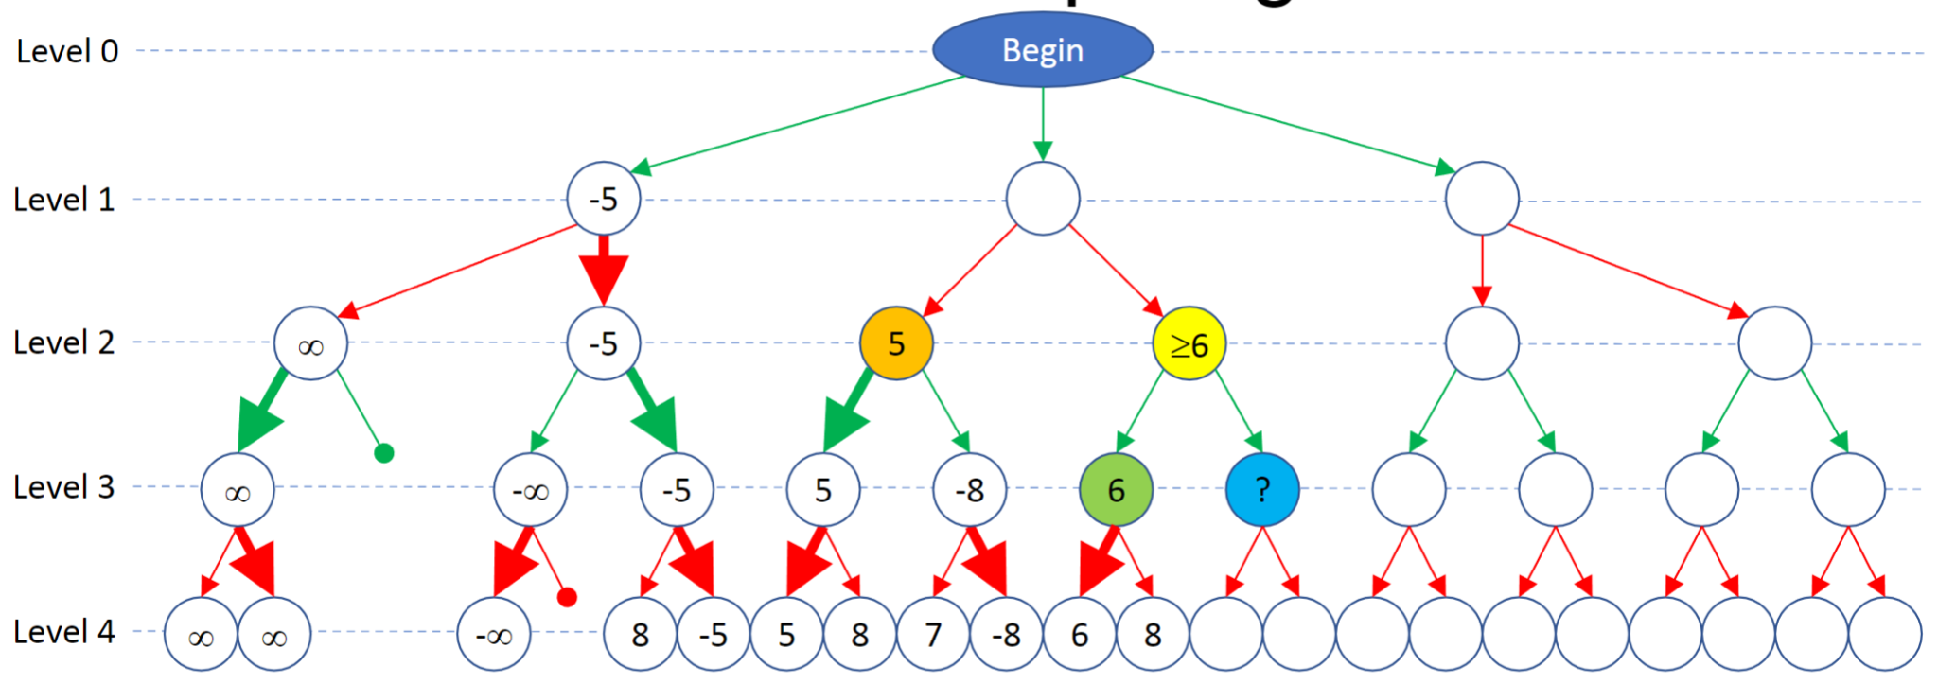
Figure 7: Alpha-Beta Pruning Tree

At the move on level 2 shown, player two (red) wants to minimize the score shown on the nodes. Player one (green) wants to maximize the scores shown. The model searches the orange node and finds that it will have a score of 5. Considering the green node and that player one wants to maximize the score, the yellow node will always have a score of at least 6, despite what the blue node’s score is. This is already greater than the orange node’s score, and given that player 2 is aiming to minimize scores, player 2 will choose the orange node every time. This means that the blue node doesn’t need to be searched and can essentially be cut off.

By applying this principle to every decision in our minimax algorithm, we could improve model search times by a factor of four. However, in testing, we found the model to be too slow and failed to beat experienced human players. Thus, we began to explore other algorithms.

B. Monte Carlo Tree Search (MCTS)
At first, the scope of our project was simply to code the rules and play style of Blokus to let a human player compete against an AI coded by our version of a minimax algorithm. We were able to code minimax and its variant with alpha-beta pruning in a short time block. Because of Blokus’ complexity, the results of minimax were encouraging, despite being far from super-human. Unfortunately, minimax’s weakness was emphasized by Blokus’ extreme branching factor.

After substantial research and mathematical calculations of time complexity and different styles of tree expansion, we decided to pursue MCTS as the most promising algorithm. We had seen implementations of MCTS that performed well in games like Go, Chess, Shogi, or Poker with large amounts of possible games. The MCTS is able to handle large search spaces with complex dynamics and long-term strategy through a couple of key features. MCTS stood out because of its heuristic approach to expanding search trees. It is capable of asymmetric expansion towards promising states. To increase the depth and subsequently how far our code can see into the future within the same time restraints, some branches must be skipped, creating an asymmetrical tree. MCTS can balance between exploration and exploitation. Its ability to integrate neural networks to reduce the impact of random chance and human error in the long term was also appealing.

1. Structure
Our Monte Carlo tree search algorithm consisted of four steps: Selection, expansion, simulation, and backpropagation. Each iteration of these four steps is considered a simulation. Our typical MCTS ran around 500 to 4000 simulations per round.

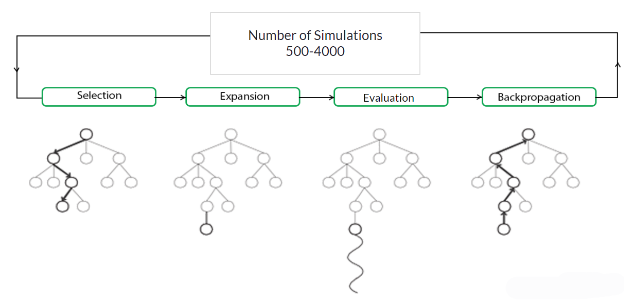
Figure 8: Four Steps of Monte Carlo Tree Search⁹

Selection
In the selection process, we traverse through the tree from the starting node by choosing the best child (determined by the ICB scoring) until an unexpanded node is reached. An expanded node is one that has not been chosen by a previous simulation. The traversed path is recorded for later use in the backpropagation step. The ICB score is a formula we coded that balances exploration (gathering information) and exploitation (using known information to achieve a good result).
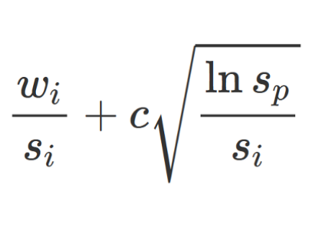
Figure 9: ICB Score for Monte Carlo Tree Search¹⁰

The first half of this equation is the value score. represents the aggregate value of the node. It is divided by , the total number of simulations that have passed through this node, to get the value score. The second half of the formula is characterized by the parent node’s number of visits over the number of child visits. The two factors are scaled by an exploration-exploitation constant. The constant allows us to adjust the style of the MCTS search. This constant proved one of the most important parameters to fine-tune when playing in competitive environments.

Expansion
After we have selected a new node, we expand the node. This is done by giving the node all possibilities of next moves as children. To access the next level of move quickly, and efficiently, we stored the children in a dictionary with the move [x,y,piece,orientation] as the key, and the corresponding board state node as the value. When we first coded the MCTS expansion step, we had no way to evaluate how good a particular move looked to explore, so we gave each child an equal chance to be chosen.

Evaluation
During the evaluation step, we face the problem of predicting the win probability of a board at an intermediate tree level. In a game like Blokus, simulating a terminal state (win, loss, tie) consumes too much time and resources. To evaluate the board position, we constructed a complicated evaluation function based on what human goals were throughout the game. Some of the main quantified values were the number of pieces placed, the number of available corners for each player, and the location of available moves.

Our humanistic board evaluations had some flaws because it was goal driven, when in reality the only driving factor for each move should be the resulting terminal state. Humans are unable to assess terminal states throughout the majority of the game, so it would be very difficult for us to code an evaluation that looked at the terminal state probabilities, instead of breaking down the game into smaller tactical goals.

When we implemented the board scoring, we noticed some shortcomings. The MCTS was incapable of planning beyond the states it had visited. The algorithm was mostly static throughout the game. Some unique board positions require particular evaluation priorities that were not taken into consideration. Finally, not all strategies are easily quantified. Spatial recognition and box planning were strategies humans implemented quickly, yet were difficult to impress upon the AI.

Backpropagation
After deciding on the value of a node, we update the values of each node in the search path. This section of our code relates strings of moves together and makes board states depend on what future states it may lead to. Each move we make is not independent of future positions. How successful a move is valued must depend on the future states of the game playing that move will lead to.

2. Implementation of MCTS
Writing the code to perform each of the four steps of a simulation correctly and efficiently was a complicated task that took much longer than implementing minimax. Our first version of MCTS performed substantially worse than we had hoped. The methodology behind the ICB score was flawed and, our code would explore promising nodes to an unhealthy extent and miss better or more crucial moves. This version did not perform well against other algorithms and was not tested against humans.

The second iteration of MCTS was somewhat successful but took minutes to run ~1000 simulations. The structure of where values, trees, and objects were stored and passed from one state to another was inefficient and redundant. The outcomes, while slow, performed much better versus random and minimax with dominant win rates (94% and 79% respectively). This algorithm was still only somewhat effective versus experienced humans (we consider expert players to be players who have played for years and have strong mathematical or strategic backgrounds). However, it did achieve wins against newer players, making it the first of our algorithms capable of beating some humans consistently.

Our third coded construct of MCTS became our final structure, but the details of trade-offs and board scoring would continue to be fine-tuned. When we coded this version, we reduced the amount of redundant information to a minimum and improved the data structures holding the MCTS data. We also changed the way parent nodes were affected by their children’s values to be more penalizing. This allowed the algorithm to run almost 100 times faster than version 2. MCTS could explore much deeper into the tree states, often reaching 30-35 layers deep in important board states. We played this algorithm against humans and other bots, but it achieved only slightly better results. Experienced human players were still able to outperform the MCTS that optimized for the best board-scoring outcomes. In the Monte Carlo algorithm’s eyes, it might view losing states as favorable because of the current evaluation style.

We had a breakthrough when we realized that the very deep searches were capable of reaching terminal states beyond just the end game. Changing the simulations to be quicker allowed us to reach terminal states much faster and more often than before. Because we are able to reach terminal states, the board scoring meant to evaluate how good an intermediate board looks is no longer always necessary. Instead of working towards short-term goals, we could search for favorable terminal states after a couple of rounds of play. We adjusted the evaluation of a node to depend on the board scoring for the first 4 moves. It then transitioned to valuing the win, loss, or tie outcomes as well as the score differential between the two players for each subsequent game. This algorithm performed extremely well versus other computer programs. Using ~500 simulations, it beat random, minimax, and PPO with 98-100% win rates when going first. While these wings were very impressive, we were most interested in their ability to beat advanced human Blokus players consistently. The MCTS v3 won 60-70% of games against expert players when run at ~700 simulations. Even at only 50 simulations, the MCTS v3 was able to occasionally beat human players. This was most unexpected because we expected 50 simulations to be insufficient search time.

The number of simulations was the primary factor in how well MCTS plays. It is essentially the number of looks into the game tree. There are exponential strategic returns from 50 to 1000 simulations. When playing at around 50-100 simulations, the MCTS is able to explore some moves, but with the high branching factor of Blokus it is not enough to find optimal moves. Playing at 500-700 simulations allows the MCTS to probe deeper into the tree and find long term rewards or punishments to particular moves. The main limiting factor is the time it takes to run. Running under a thousand simulations takes 20-40 seconds, which we deemed a suitable time frame.

3. Strengths & Limitations
The MCTS algorithm performed exceptionally well despite its flaws. With enough simulations in a reasonable time, it was able to beat the best Blokus players we could find. I would not consider the MCTS to be “superhuman” yet because humans who played against it enough times would realize patterns in the MCTS plays. After continued gameplay experience, humans were then able to counter MCTS to some extent.

There were four main limitations of our MCTS algorithm at this point in time:
- After many simulations, it requires large amounts of memory.
- Not every possibility is searched. Complicated losing patterns may not be explored.
- Possible moves are explored randomly at first. Trees had large breadths.
- Board positions are evaluated by a human algorithm or by simply the score.

The first two limitations are impossible to remove from the MCTS architecture. We can continue to improve the storage, but the mominimal amount of data stored is still very large. The reason MCTS performs better than minimax is that not every possibility is searched. Because we have time restraints when playing a game, the limitation of being a heuristic is necessary.

C. Monte Carlo Tree Search with Convolutional Neural Networks (CNNs)
Can we skip or disregard some moves given a position? Do some moves deserve to be explored more thoroughly?
How can we better estimate the winning probability when stopping at an intermediate tree level?

1. Improving MCTS with CNNs
Some of MCTS flaws can be addressed through the use of convolutional neural networks. We built these models using Keras Sequential models. The value network is used to estimate a win probability given a board state. It outputs a value ranging from [-1, 1]. A -1 signals a guaranteed loss, and a 1 means a guaranteed win. This network will better estimate the win probability of a state without reaching a terminal state. Its goal is to reduce the depth needed in our search trees and to replace the humanistic board scoring function. The policy network assesses which moves are worthwhile to explore when a new node is expanded. Given a boast state, it outputs an array of probabilities that exploring a given more will lead to a win. These probabilities add up to one and replace the equal probability originally given to new nodes during expansion. Some moves are deemed more important than others to explore, and this eliminates the chance our coded MCTS algorithm wastes time looking at unusable moves, similar to a human choosing which pieces to think about playing.¹²

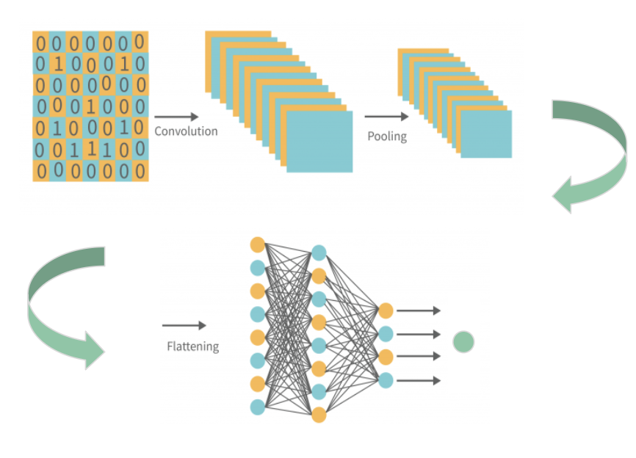
Figure 10: Model Architecture Choice CNNs¹²

2. Model Architecture Choice: CNNs
Boards are very similar to a low resolution image. Based on our previous experience with image segmentation and object recognition, we decided that a convolutional neural network may perform well for Blokus. The CNN will assess the values of each position along with the positional relationships.

3. Data Gathering
To train our CNNs with supervised learning, we first needed to collect sufficient amounts of data. We performed hundreds of thousands of simulations between different players:

- Random
- Minimax version 1 and 2
- MCTS
- MCTS - CNNs

Running games and gathering data times significant amounts of time and computing power. We utilized an entire computer lab to run games at once. We synced the room (46 computers) together, with one computer collecting all the data before pushing to an external hard drive. For each turn within a game, we collected the data shown in Table 1.

Table 1: Data Collected per Turn
Board | [[0, 0, 0, 0, 0, 0, 0, 0, 0, 0, 0, 0, 0, 0, ], [...
Moves | [[3, 4, 14, 5], [5, 4, 14, 5], [4, 4, 5, 1], [...
Move Probabilities | [0, 0, 0, 0, 0, 0, 0, 0, 0, 0, 0, 0, 0, 0, 0, …
Reward | 1
Weights | [10,465979410463808, 1.3248101796886176, 1.681…
No. of Simulations | 1345
Model Type | monteCarlo
Inventory | [3, 4, 7, 13, 19]

The board states for recorded relative to the player because for each turn we can get a set of information from the point of view of both players. Only one player will be playing on that turn but flipping the board state’s values and calculating the opposing player’s data proved a very useful data augmentation strategy.

4. Value Network Architecture
The structure of the value network relies on a board state for input and outputs a value from [-1, 1] representing how favorable the board looks. This network evaluates the quality of Blokus board positions rather than predicting moves. It helps my MCTS assess whether a position is likely winning or losing. The value networks needed to have a degree of inaccuracy. Game performance peaked around~ 28% accuracy of the value network. We achieved those results through a high dropout layer following each dense layer. While lower accuracy improving performance may seem counterintuitive, the value network is not intended to function on its own. If the network was too confident, it would disrupt MCTS’s exploration exploitation trade-off and hurt overall performance, especially against human agents. Refer to Appendix 3 for detailed information on model layers and composition.

5. Value Network Abilities
Even with minimal architectures and fine-tuning, The winning probabilities estimates were better than the human board evaluation by a significant amount. The value network was also much more resistant to going second than any previous algorithm. We observed that when implemented with the MCTS framework, the value network demonstrated more complicated attributes, such as spatial blocking, long-term piece forcing, corner importance, and being dynamic throughout the length of the game.

6. Policy Network Architecture
To implement a policy network that can output a set of move probabilities for any board state, we had to define the action space of Blokus. A universal CNN requires a fixed set of total moves and this was done by assigning each possible move (14 x-coordinates, 14 y-coordinates, 21 pieces, 8 orientations) a number, resulting in 32,928 possible moves (though some of these will never be legal).

From a given board state, many of the elements of the action space will be illegal. While the policy network will often assign the illegal moves probabilities very close to 0, some may be slightly positive. To eliminate illegal moves, we implement action masking. That is when we set illegal move probabilities to 0 and regularize probabilities so they add back to 1. As CNN trains, it realizes that setting illegal moves to a non-zero probability hurts its accuracy.

7. Two Stages of Development:
The policy network typically has two levels of development. Due to our time restraints, we only pursued the first stage in context with the MCTS algorithm. The second stage was constructed separately as a proof of concept to how such a network would work.

Supervised training
The first state of the policy network is the supervised training stage. The policy network trains on large data frames containing pre-played games between different kinds of algorithms. The data generated over a couple of days was used in coding our policy network, although we did not have time to train on the entirety of the data collected. Given more time, we would have gathered much larger amounts of data as well as create different, more advanced distributions of information by playing stronger bots against each other.

The goal of the supervised learning stage is for the policy network to achieve approximations for mapping board states to moves. The policy network after this stage had two main effects on the gameplay of the MCTS CNN algorithm. Fewer simulations were needed to achieve the same results because the MCTS will be less likely to waste simulations looking at moves it would disregard anyway. The breadth of the tree searches were limited. The second, more surprising outcome was the policy network recommending more searches into moves that appear harmful at first but may have potential farther in the game. Our model did not achieve the ability to set all illegal moves to near zero values, and therefore the probability distribution was diluted more than we had hoped after action masking and regularization of the probabilities. Our model achieved what we considered “expert” level by the end of our research. It learned many strategies intuitive to humans, because the bots that played the games the model was trained on utilized our humanistic board scoring algorithm.

Reinforcement Training
Given more time, we would have transitioned our policy network to train by reinforcement learning. To retain most of the weights from the policy network, we would have frozen most layers and trained the last 3 dense layers. Instead of training on previously played games, the second phase of the policy network would train in games against itself, using the results to facilitate reinforcement training. This technique is very similar to the PPO discussed later in the paper. Our hope was that after this stage, the policy network would refine its probabilities to assess benefits towards only the terminal states.

8. Integrating the CNNs into the MCTS
Both the CNNs were tested individually before combining all the parts together. The value network at first fully replaced the board scoring function. After a couple dozen games, we realized the value network, while it had useful insights, was not accurate enough to be the sole guiding factor of MCTS evaluation. With limited time and data, we decided to supplement the value network with the board scoring function. The function followed the same strategy of utilizing many different weights for the first couple moves before transitioning to using only the score differential. For each move, the evaluation was averaged between the value network score and the board scoring output. This formula of evaluation was used in our strongest bots for MCTS with CNNs. The policy network when first implemented instead of random possibilities for an expanded node’s children performed well but with a key downside. The policy network would assign some of the legal moves a 0 or very near 0 probability, encouraging the MCTS to never explore those moves even after masking and regularization. The network likely did not have enough training to recognize legal and illegal moves in such a large move space of almost 33,000 moves. To counter this, we changed the redistribution after action masking. We coded the illegal moves to 0 probability and then increased each of the legal probabilities by equal amounts instead of proportional amounts. With this change, the policy network was able to recommend which moves to explore while making sure no move had a zero chance of being chosen.
9. What separates our algorithm from AlphaGo
AlphaGo used a similar approach to playing Go as we took to tackle Blokus. AlphaGo also used an MCTS algorithm aided by a policy and value network. The key difference is that AlphaGo never used a board scoring method developed by the coders. AlphaGo learned purely by the results of wins and losses. The human made board scoring attempted to break down the game strategy into intermediate goals and look to complete tactics and strategies to reach those goals. While Blokus and Go are very different games, it is likely that the AlphaGo framework would have performed well in Blokus environments. The reason we did not pursue that kind of architecture was it would depend too heavily on the CNNs. We were missing a couple of requirements to make it feasible. First, we would have needed an extensive data set of expert human games to train the first iteration of the policy network. Second, the strength of the CNNs needed to perform well would have taken more time with stronger computers than we had access to. Finally, hyperparameter tuning over different iterations of trained models would have taken much longer than the time available to us.

D. Proximal Policy Optimization
A more modern approach to solving board games is multi-agent reinforcement learning using a Proximal Policy Optimization (PPO) algorithm. Published in 2017 by OpenAI, PPOs use several epochs of minibatch updates to optimize an objective function with a stochastic gradient descent (SGD), gaining benefits of the trust region policy network algorithms with advantages for continuous or very large action spaces.¹¹

1. Overview
This implementation requires a set of standardized frameworks and components for training and agent-environment interaction. At its core, it functions as an agent or multiple agents interacting with an environment and getting a reward as feedback.

2. Implementation
The environment utilizes PettingZoo’s AECEnv which enables multi-agent environments such that two players can be trained at once (sequentially, rather than in parallel).¹³ Stable Baselines 3’s MaskablePPO is used for training because of its simplicity and Pythonic structure.¹⁴

The observation space consists of the board state and the pieces left in each player's inventory. The board can be represented as a 14 by 14 matrix with integer values which are standardized where each agent recognizes a 1 as its own spot and a 2 as an opponent's spot. The inventory can be represented with a 2 by 21 array where a binary value indicates the availability of a piece for either player. The true action space in the environment consists of a MultiDiscrete OpenAI Space which combines flattened and concatenated arrays of board and inventory. Separately passed, a MultiBinary object represents the action mask for every move in the action space. Table 2 indicates the composition of the observation space.

Table 2: Observation Space of Blokus Environment
Feature | Domain | Length | Notes
Board |  |  | 0: No block played  1: Agent block played  2: Opponent block Played
Pieces |  |  | 1 - 21: Agent inventory  22 - 42: Opponent inventory  0: Block used  1: Block available
Action Mask |  |  | 0: Illegal move  1: Legal move

The action mask is composed of a series of discrete spaces which are made to represent the x-coordinate, y-coordinate, piece number, and orientation of a piece in any given action on the board. Due to the large number of possibilities of the action space (32,938 actions), it is unfeasible to use a negative reward to make the model learn what moves are legal. Rather we use the underlying Board class that was used in previous algorithms as a game logic engine which is able to mask all invalid moves and set their probability to zero while adjusting valid move probabilities accordingly.¹⁵ Table 3 describes the action space in detail. Since the action mask modifies the way the action space is treated, the action space becomes a single Discrete environment with a domain that can be converted back to human-readable (more similar to those shown in Table 3).

Table 3: Action Space of Blokus Environment
Feature | Domain | Length | Notes
X-coordinate
Y-coordinate
Piece |  |  | Increasingly masked as player inventory shrinks
Orientation |  |  | Largely masked since many orientations are duplicates

In terms of rewards, the basic +1 and -1 rewards were assigned to agents on winning and losing, respectively. Experimentation using +n rewards was conducted where n is the number of tiles on a piece as well as -50 rewards on illegal moves before action masking was implemented. Rewards relative to piece size were shown to encourage the placement of large pieces rather than strategically advantageous ones and could easily push the agent into a corner from which they could not escape. In reality, large pieces are more advantageous in the first few moves and then should be played strategically. The -50 reward for illegal moves was ineffective in training the model to learn the rules and was ultimately useless after the implementation of action masking.

The model itself was trained with the entropy coefficient set to 0.005 and the learning rate of the optimizer set to 0.001. Over ~100,000 timesteps (~4,000 games), the model (as player 1) achieved a win rate of about 98.38% against a random agent as shown in Figure 11 of section III.

3. Strengths & Limitations
PPO is arguably best known for its ability to handle complex environments with large action spaces, as well as multi-agent environments. It is overall a very versatile model. It is also relatively quick for implementation and has a relatively low computational requirement. When playing against the model, it was able to compute moves much quicker than minimax did on the same hardware. Unfortunately, it would require thousands of more games and actions to be able to make a reliable inference for either agent. Though the model was able to play well against random moves, it struggled to form true strategy that competed with a human strategy, likely due to a lack of learning. Given more time, this model in theory could have outgrown MCTS and been a more viable model due to its speed of prediction.

III. Results
When running completely random simulations of play, the win rate leans towards the player who makes the first move. In fact, over many games it is also clear that when player 1 wins, they will often win by more points than player 2 wins by, on average. This data is illustrated in Table 4. Assuming an expected ratio of a 45% win rate for each player and 10% of games ending in a draw, a χ²-GOF test shows that these results are significantly different () and independent one sample z tests for proportions showed that both players differed significantly from a 50% win rate (). Ultimately, there is a clear winning bias towards player 1.
Table 4: Random Simulation Win Results

P1 Wins | P2 Wins | Draws | Total
2635 | 2024 | 341 | 5000
52.7% | 40.48% | 6.82% | 100%
P1 Avg | 51.8726 | P1 Avg “win by” | 4.5574
P2 Avg | 50.292 | P2 Avg “win by” | 2.9768

Figure 8 demonstrates the win rate of the PPO model as player 1 against a random agent recorded every ~10,000 steps. Overall it demonstrates a positive trend except for the outlier of ~40,000 time steps, likely the result of a poor exploration that is easily recovered. Due to seeding issues, the model that was stopped did not outperform the best model, which gave a 98.38% win rate after ~100,000 continuous time steps.
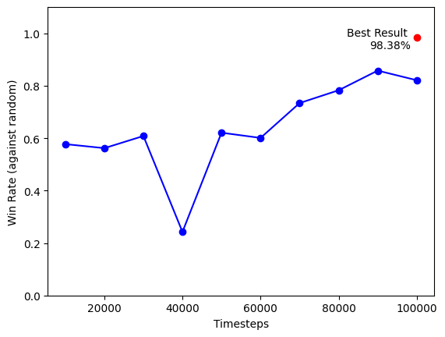
Figure 11: Win rate of the PPO model over time steps

Then, we ran simulations of our models against each other, results shown in Table 5. When gathering this data, we ran about 2,500,000 simulations in total, not including the simulations involving the PPO. For these tests, we used Minimax version 3, PPO version 1, and the Value Network in the CNN. Since the PPO was finished later, we ran about 50 simulations when the PPO went against the other non-random algorithms, thus our sample size is much smaller than other matchups. However, PPO versus random matchups were run extensively. The results for the PPO against the minimax algorithm are omitted as given that both are deterministic, and the starting state is always the same, the sample of games will always be a repetition of a single game resulting in unhelpful and misleading win percentages (always 100%). Additionally, we could not simulate the PPO against the MCTS with the CNN due to time constraints. However, we can assume that the results for the MCTS with the CNN would be similar to the MCTS’s results, as the other results of both against the other algorithms are similar.
Table 5: Player 1 Win Rate (%) Against Player 2

Player 1
Player 2 |  | Random | Minimax | PPO | MCTS | MCTS w/ CNN
Player 2 | Random | 52.7 | 90.63 | 98.38 | 100.00 | 100.00
Player 2 | Minimax | 34.78 |  |  | 98.44 | 98.82
Player 2 | PPO | 61.29 |  |  | 100.00
Player 2 | MCTS | 0.00 | 8.65 | 12.31 |  | 66.09
Player 2 | MCTS w/ CNN | 0.00 | 3.65 |  | 51.55

IV. Conclusion
Minimax, despite its simplicity, performed well, having a high win rate in random agent benchmarks and was able to win against beginner-level humans. Even though it had minimal training, the MCTS with CNN was the approach that resulted in the highest win rates compared to all the other methods. MCTS without CNN had competitive win rates compared to the MCTS with CNN. MCTS and MCTS with CNN were both able to win against experienced humans. The PPO model performed poorly, likely due to lack of training data and hyperparameter optimization. Despite having a solid performance in a random agent benchmark, human play and play against other algorithms revealed PPO’s flaws.

V. Future Direction
Given more time, we can implement the PPO as part of the second phase of the policy network in the MCTS with CNN, which would further improve it. Additional refining of our code would lead to a faster runtime, allowing for an improved user experience. Our future direction may include more complicated networks like AlexNet trained on much larger datasets. Finally, we would play our advanced AIs against more humans.

VI. Code Availability
All the code created for this project is available at https://github.com/JJFrisch/BlokusDuo and its various branches.

VII. Acknowledgements
We would like to thank our project advisor Dr. Neil Simonetti and our dedicated teaching assistant Tripp Hoover who helped us immensely throughout this project. We would also like to thank Ogechi Anyamele and Ashley Driesbach for their valuable roles as human testers and Mr. Andrew McGuier for helping to provide us with more storage and providing additional support. Finally, we would like to extend our sincere gratitude to the PGSS Alumni Association and all the faculty and staff of PGSS for giving us this incredible opportunity.

VIII. References
¹“Blokus Discoveries.” www.gotfriedville.net, https://www.gottfriedville.net/blokus/, Annotated

² “Deep Blue.” www.ibm.com, https://www.ibm.com/history/deep-blue

³ “Kasparov vs. Deep Blue | The Match That Changed History.” chess.com, 12 Oct. 2018,
https://www.chess.com/article/view/deep-blue-kasparov-chess

⁴ “AlphaGo.” Google DeepMind, https://deepmind.google/technologies/alphago/

⁵ Silver, David, et. al. “AlphaZero: Shedding new light on chess, shogi, and Go.” Google DeepMind, 6 Dec. 2018, https://deepmind.google/discover/blog/alphazero-shedding-new-light-on-chess-shogi-and-go/

⁶“The Barasona Opening.” BoardGameGeek,
https://boardgamegeek.com/image/112251/blokus

⁷ “Common Beginner Mistakes.” Pentolla.com, https://pentolla.com/beginner/node1.shtml

⁸ “Algorithms - Minimax.” cs.stanford.edu, https://cs.stanford.edu/people/eroberts/courses/soco/projects/2003-04/intelligent-search/minimax.html

⁹ MCTS/UCT in solving real-life problems - Scientific Figure on ResearchGate. Available from: https://www.researchgate.net/figure/Four-phases-of-the-MCTS-algorithm-The-figure-replicates-an-illustration-presented-in-3_fig1_320003615 [accessed 26 Jul 2024]

^{10 ​​}Browne, Cameron, et al. “A survey of monte carlo tree search methods,” IEEE Transactions on Computational Intelligence and AI in Games, Vol. 4, No. 1, (March 2012).

¹¹ Schulman, John, et al. “Proximal Policy Optimization Algorithms.” arXiv.org, (28 Aug. 2017), https://arxiv.org/abs/1707.06347

¹² “​​CNN Architecture – Detailed Explanation.” InterviewBit, June 10 2022. https://www.interviewbit.com/blog/cnn-architecture/.

¹³ Terry, J, et al. “Pettingzoo: gym for multi-agent reinforcement learning,” Advances in Neural Information Processing Systems, Vol. 34, pg. 15032-15043, (2021).

¹⁴ Hill, et al. “Stable baselines.” GitHub. https://github.com/hill-a/stable-baselines.

¹⁵ Zouitine, Adil. “Masking in Deep Reinforcement Learning.” boring-guy.sh, 16 June 2022, https://boring-guy.sh/posts/masking-rl/.

Previous blokus players;
https://digitalcommons.calpoly.edu/cgi/viewcontent.cgi?article=1305&context=cpesp
https://teaching.bb-ai.net/Student-Projects/project-reports/Games/Sharon-Mathew-Blokus-project-report.pdf

IX. Appendix

A1: Smart Turn Code

# Algorithmic method to determine the best possible move for a given board
# state. This iteration uses minimax.

def smartTurn(self, level):
# Generate a list of all legal moves that we will then search through.

move_list = self.calculateLegalMoves(only_fives_rounds = 4)
random.shuffle(move_list)

# Initialize variables for the best move with an arbitrary low value.
best_val = -10001
best_move = []

# For each move in the list, we will create a temporary board and
# place the piece. Then we will run further simulation if needed
# or return the score of the board, as determined by weighting
# algorithms. Through this, we can find the best move.

for my_move in move_list:
tempBoard = copy.deepcopy(self)
tempBoard.place_piece(my_move)
if tempBoard.checkWin(tempBoard):
return (my_move)
val = self.lookahead(tempBoard, level)
if val > best_val:
best_val = val
best_move = copy.copy(my_move)
return best_move

A2: Look Ahead Code
# Method to search through possible future moves. Recursively searches
# until its depth limit is reached, where it returns the value of the
# board state.
def lookahead(self, board, depth):
# Stops recursion and returns the board's score
if depth == 0:
return board.calculateBoardScore_dots(board)
else:
# Continues recursion and continues updating best move's value
board.switchPlayer()
move_list = board.calculateLegalMoves(only_fives_rounds=10)
best_val = -9999
for my_move in move_list:
tempBoard = copy.deepcopy(board)
tempBoard.place_piece(my_move)
if board.checkWin(tempBoard):
return (-10000)
val = tempBoard.lookahead(tempBoard,depth-1)
if val > best_val:
best_val = val
return (-1 * best_val)

A3: Model Layer Composition
Policy Network V1 Layer Composition
Layer | Type | Output Shape | Parameters
conv2d_3 | Conv2D | (None, 14, 14, 32) | 1,184
batch_normalization_5 | BatchNormalization | (None, 14, 14, 32) | 128
conv2d_4 | Conv2D | (None, 9, 9, 128) | 147,584
batch_normalization_6 | BatchNormalization | (None, 9, 9, 128) | 512
conv2d_5 | Conv2D | (None, 7, 7, 64) | 73,792
flatten_1 | Flatten | (None, 3136) | 0
dense_3 | Dense | (None, 4096) | 12,849,152
activation_5 | Activation | (None, 4096) | 0
batch_normalization_7 | BatchNormalization | (None, 4096) | 16,384
dense_4 | Dense | (None, 4096) | 16,781,312
activation_6 | Activation | (None, 4096) | 0
dropout_2 | Dropout | (None, 4096) | 0
batch_normalization_8 | BatchNormalization | (None, 4096) | 16,384
dense_5 | Dense | (None, 8182) | 33,521,654
activation_7 | Activation | (None, 8182) | 0
dropout_3 | Dropout | (None, 8182) | 0
batch_normalization_9 | BatchNormalization | (None, 8182) | 32,728
dense_6 | Dense | (None, 32928) | 269,449,824

